- Design Zero-shot, One-shot, and Few-shot prompts to generate a product description for a Smart Fitness Watch.
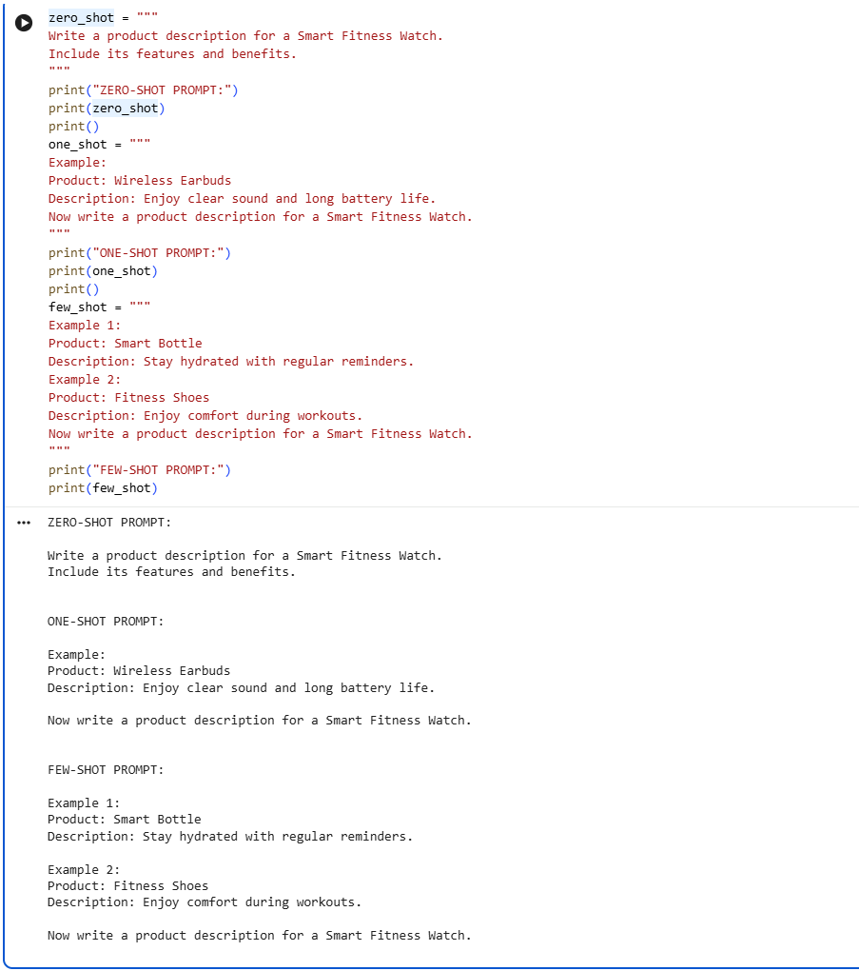

2. Design Zero-shot, One-shot, and Few-shot prompts to generate a 200-word blog on &quot;Applications of Artificial Intelligence in Healthcare.&quot;
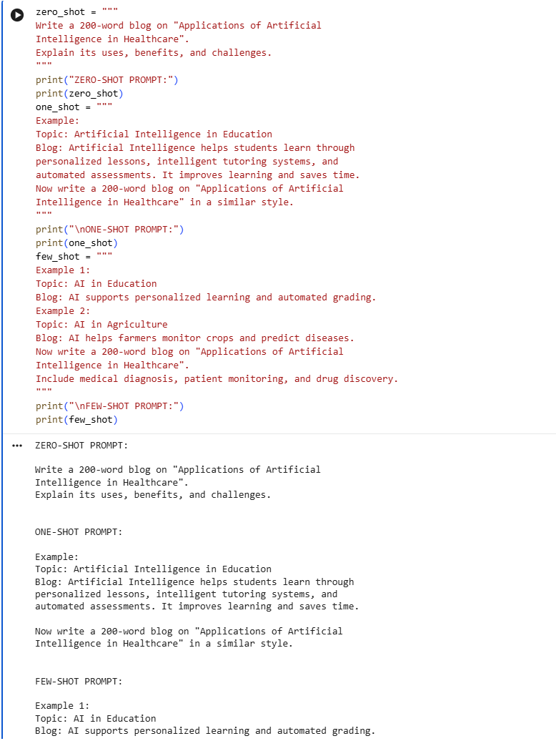

3. Design Zero-shot, One-shot, and Few-shot prompts to summarize the following article into 50 words. Compare the generated summaries based on accuracy, completeness, and readability.
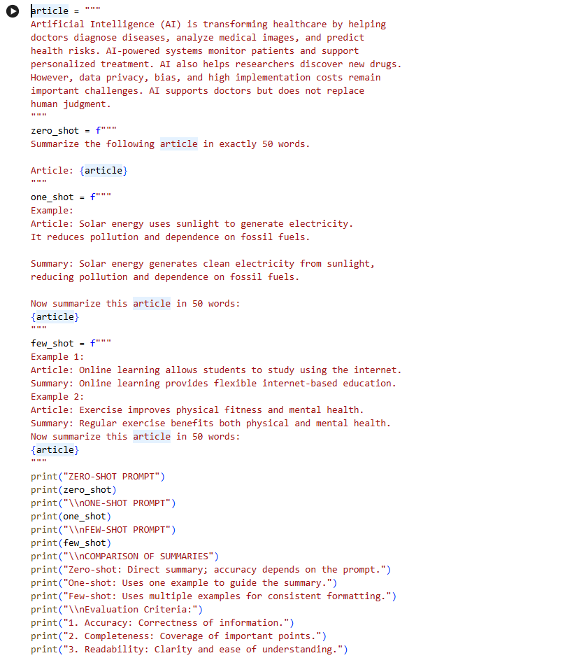
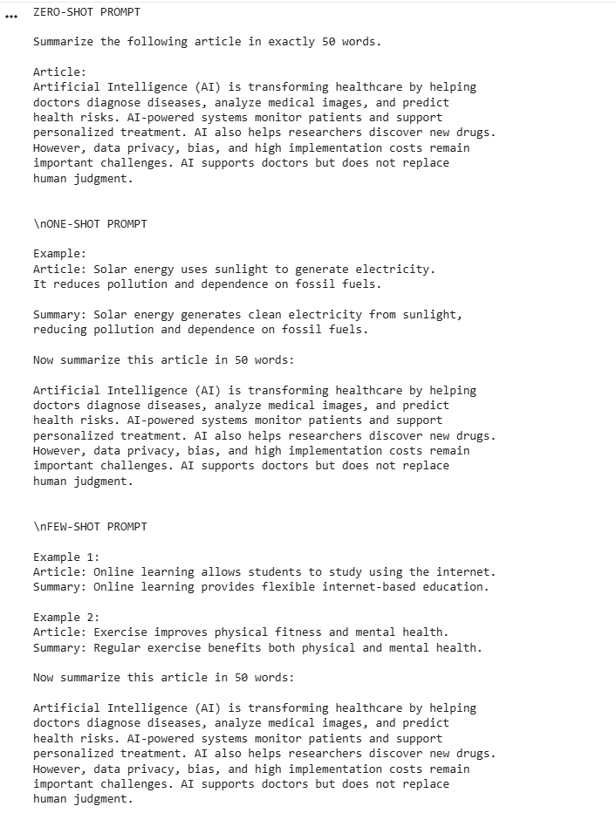

4. Design Zero-shot, One-shot, and Few-shot prompts to generate a professional email requesting leave due to illness. Compare the generated emails based on tone,grammar, formatting, and completeness.
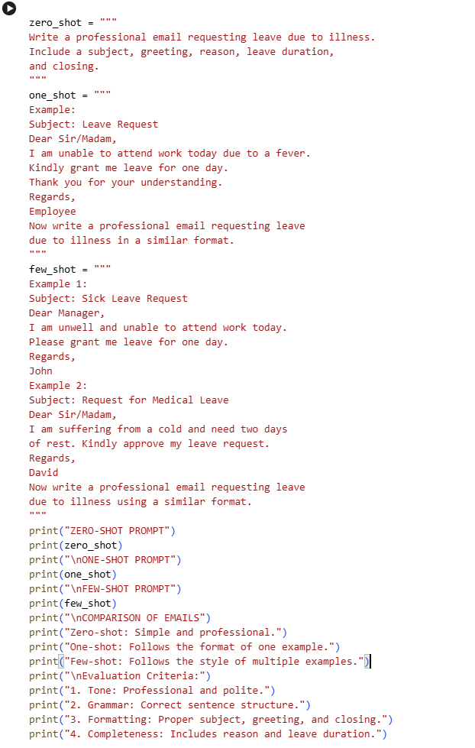
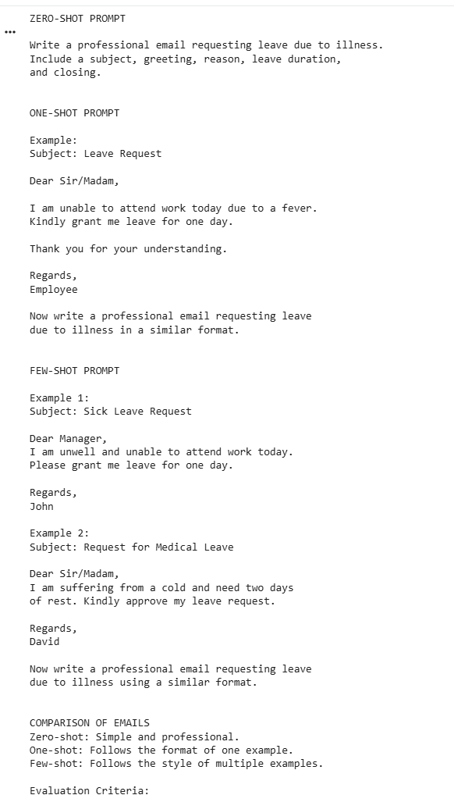

5. Design Zero-shot, One-shot, and Few-shot prompts to generate a promotional social media post for an AI Workshop.
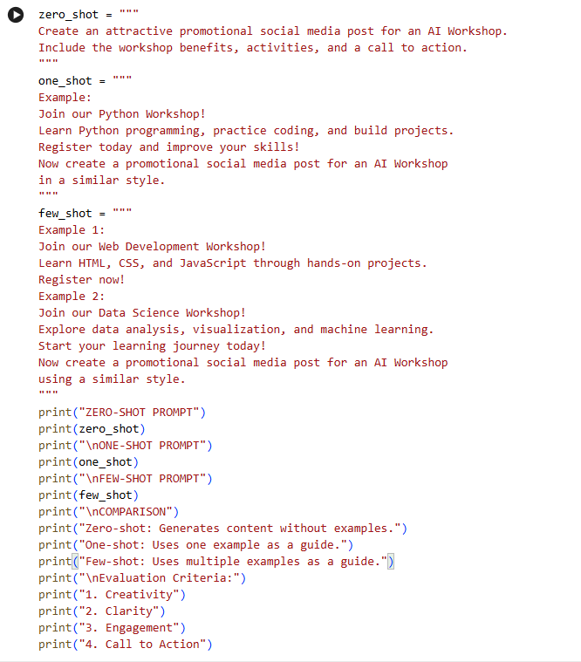
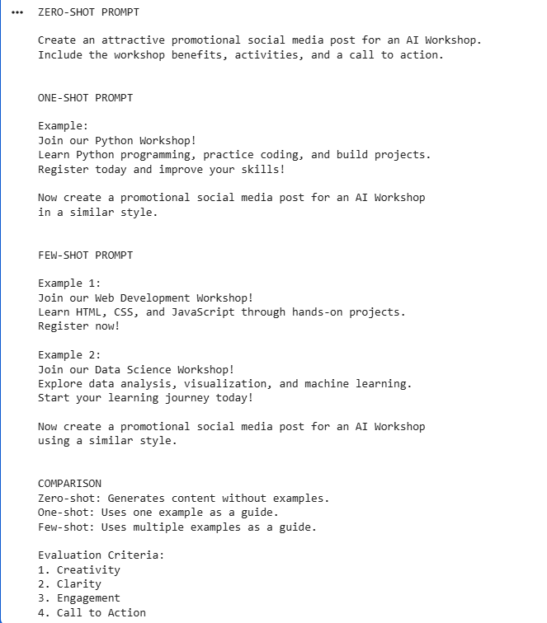

6. Text Generation using OpenAI LLM API
Develop a Python program to connect to an LLM using the OpenAI API and generate text based on a user-provided prompt.
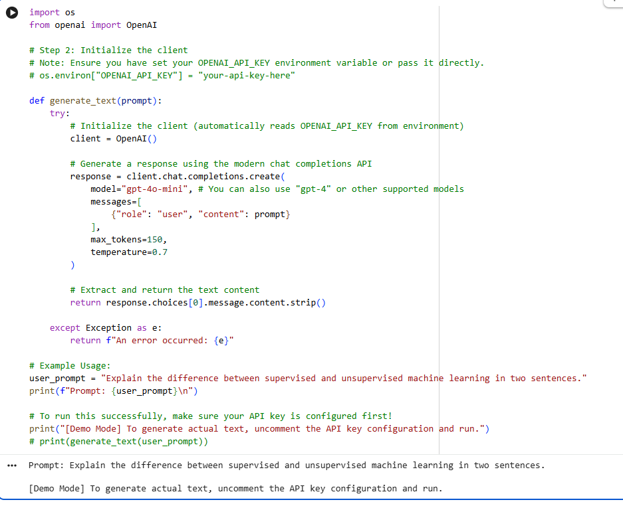

7. Text Generation using Google Gemini LLM API
Develop a Python program using the Gemini API to generate responses for different user prompts and display the generated output.
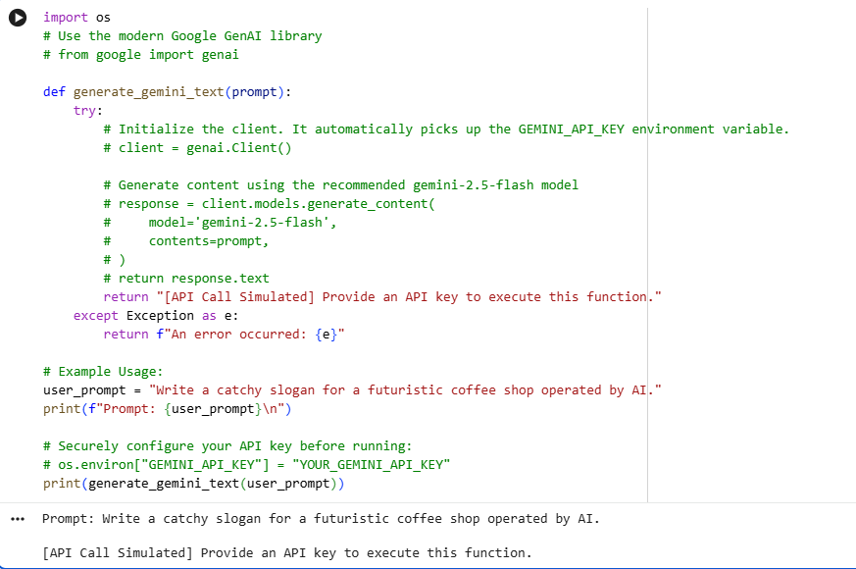

8. Text Generation using Hugging Face Inference API
Develop a Python program that uses a Hugging Face model through the Inference API to generate text from user-provided prompts.
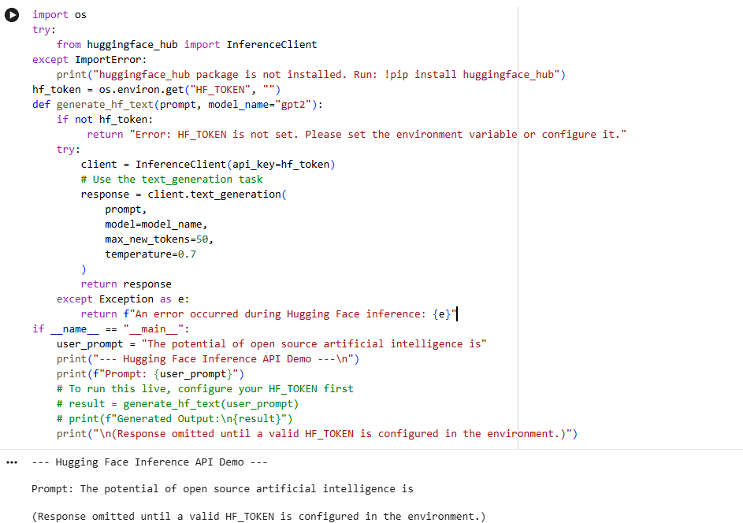

9. Python Code Generation using Structured Prompting
Design structured prompts to instruct an LLM to generate Python programs for specified computational problems and validate the generated code.
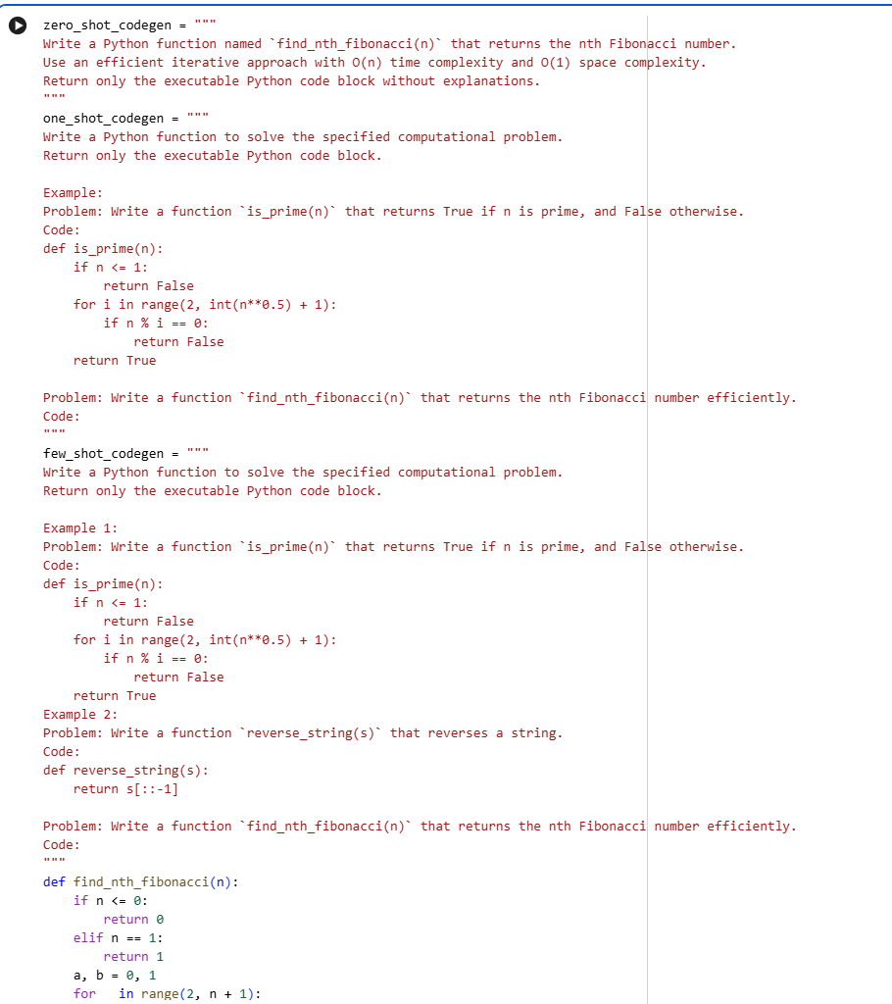
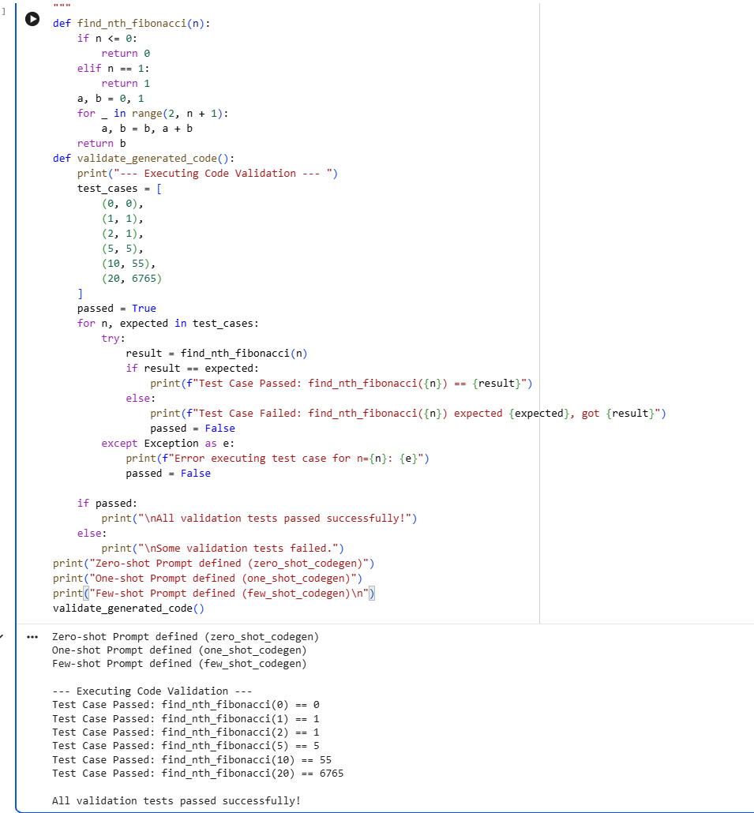

10. SQL Query Generation using Structured Prompting
Design structured prompts that provide database schema, table details, and requirements to an LLM and generate appropriate SQL queries.
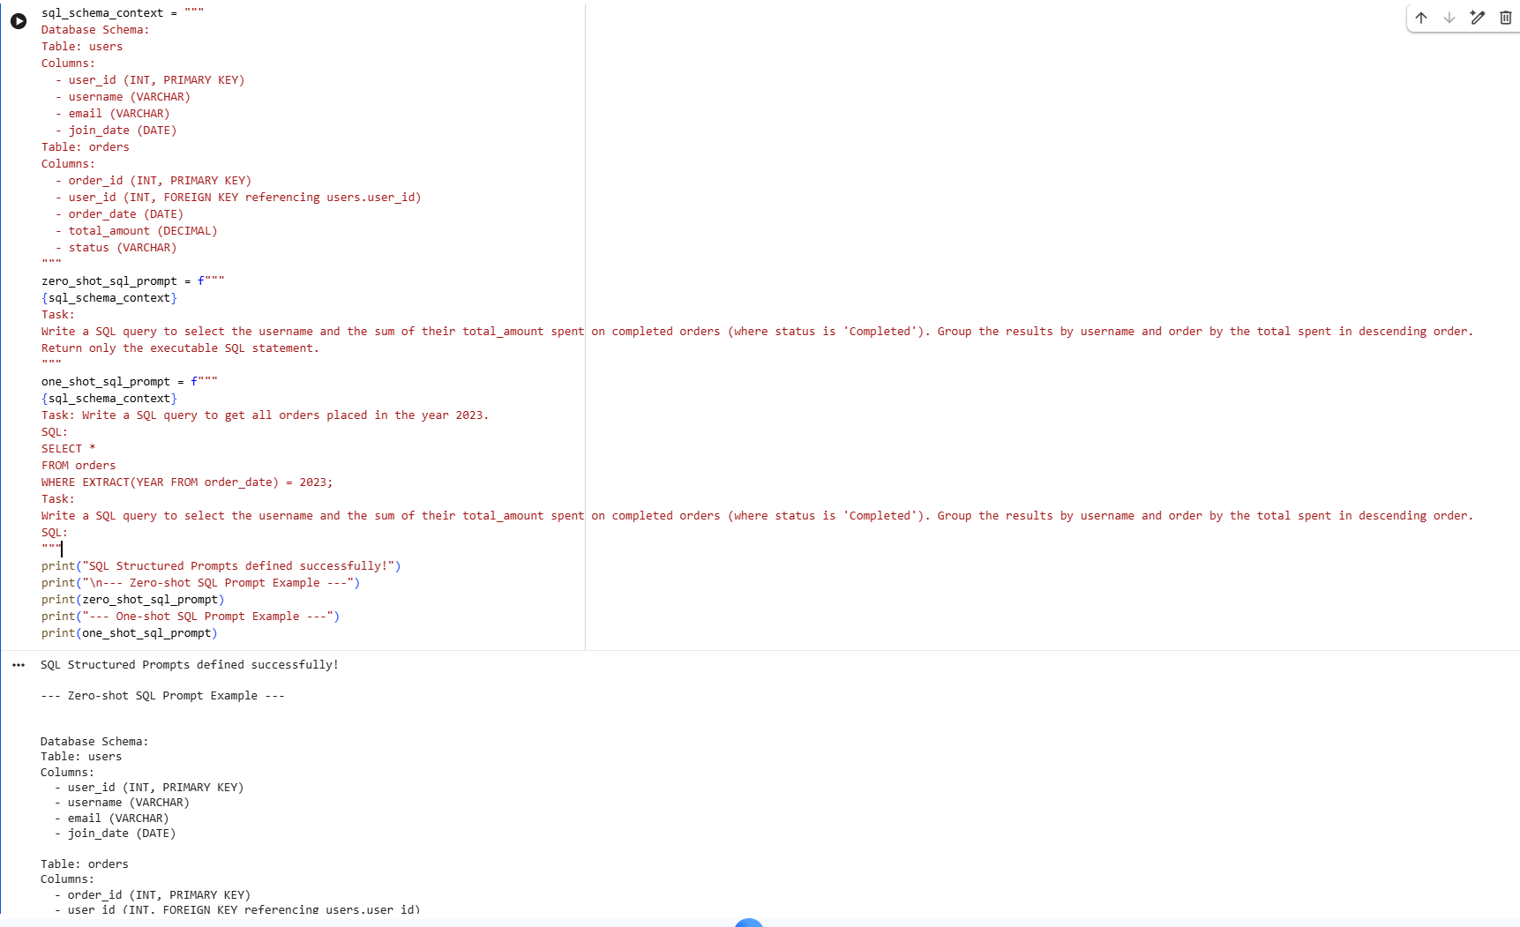
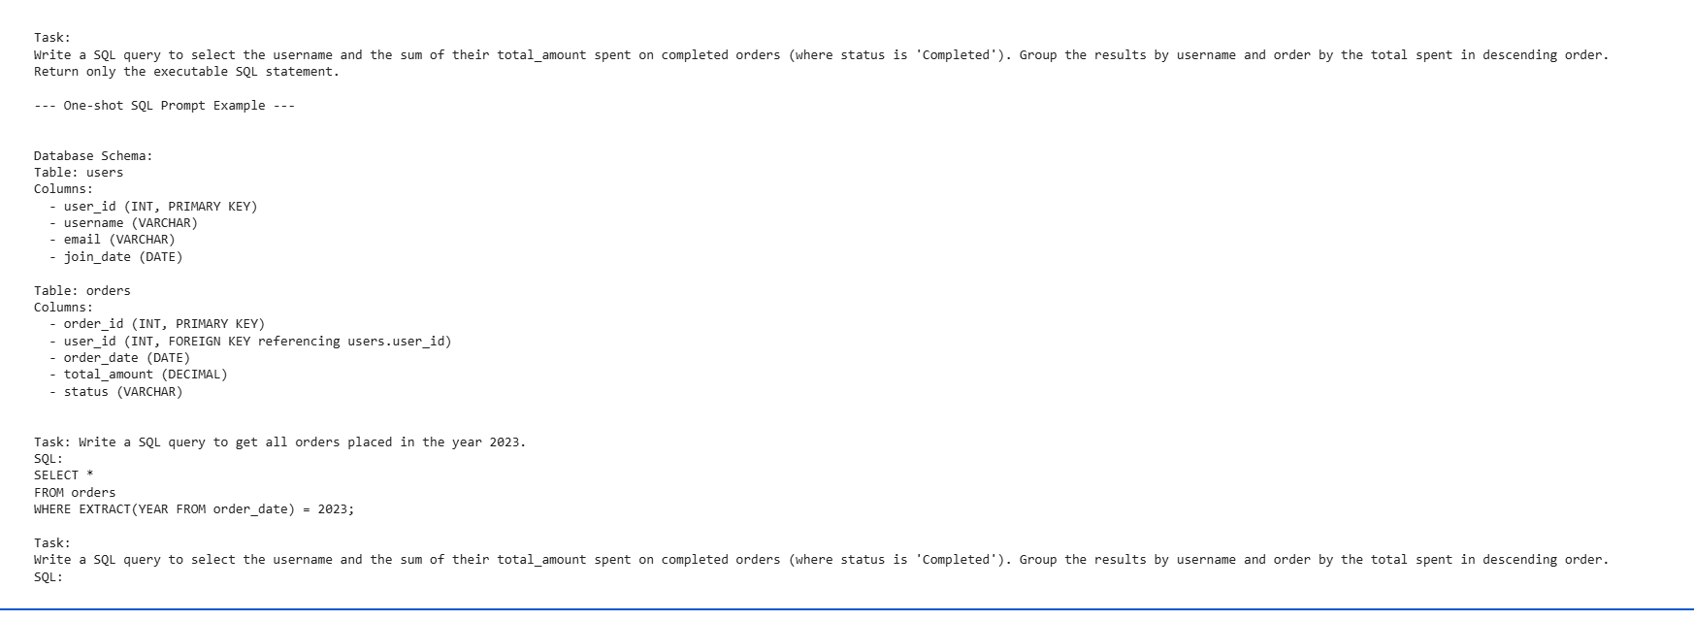

11. Comparative Analysis of Zero-shot, One-shot and Few-shot Prompting
Generate responses for the same task using zero-shot, one-shot, and few-shot prompts and compare the quality, relevance, accuracy, and consistency of the responses.

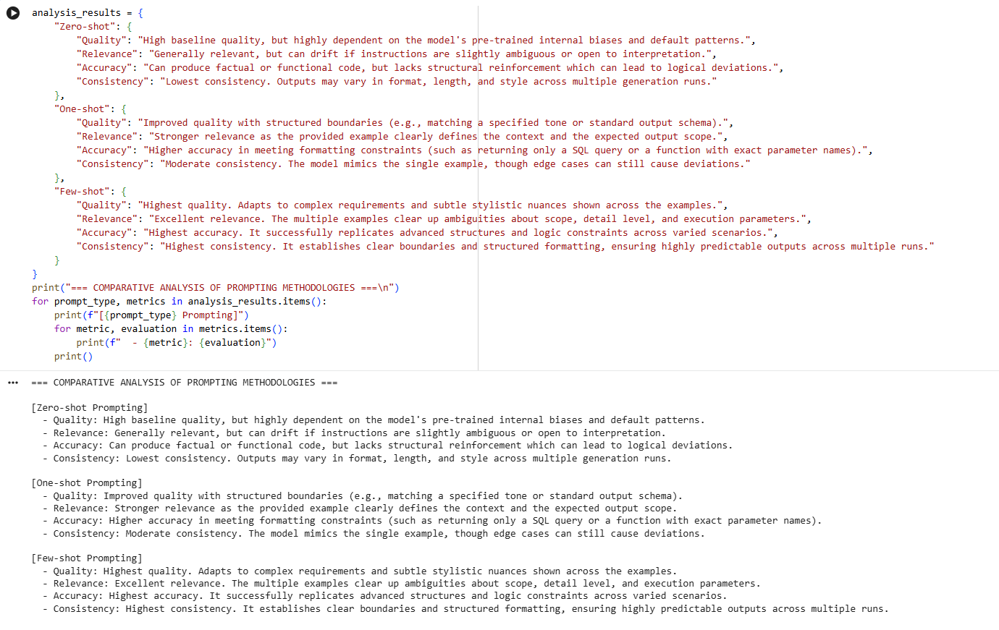

12. Prompt Evaluation, Comparison and Refinement using LLM Responses
Design multiple prompts for a given text-generation task, evaluate their outputs using predefined criteria such as relevance, accuracy, completeness, clarity, and format adherence, and refine the best-performing prompt.
